Working with MS Paint

Lesson 1
Choose one shape and filled their paper with it. Chose colors and used the paint bucket to fill in the shapes. Create your version of a shape project. Here’s a model of one below:
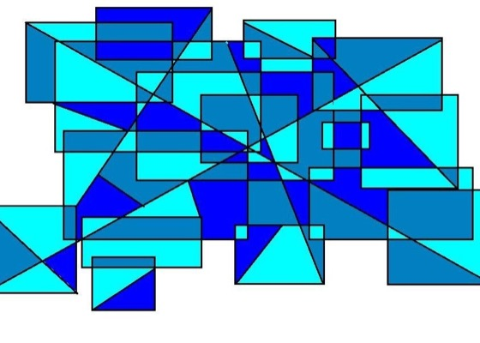

See project 2 on next page.

Lesson 2
In the next lesson, use the pencil to draw an object. After creating a basic drawing, place lines over the top to create grids. Use WARM colors to show the background and use COOL colors to show the image. Here’s a model below, but use your own creativity.
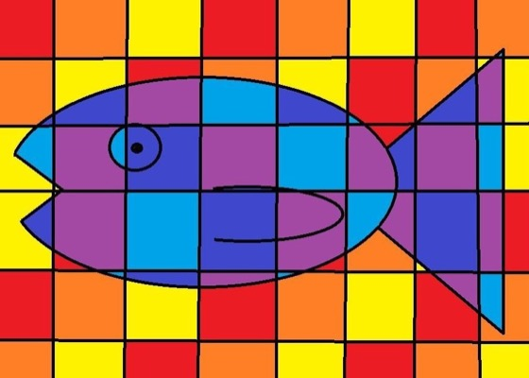
See lesson 3 on following page.

Lesson 3
Now find a black and white clipart image online. Color the image using Paint. Finally copy and paste the image to create an entire piece of art. Here’s an example below:
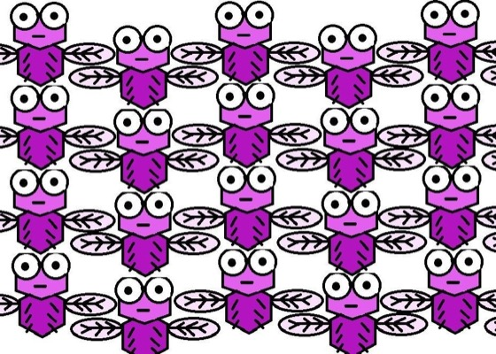

See Lesson Four on next page.

Lesson 4
Now let’s add rotation. Start by drawing and coloring one square image (create or find online and color), then copy, paste and rotate it to create beautiful kaleidoscope image like this:
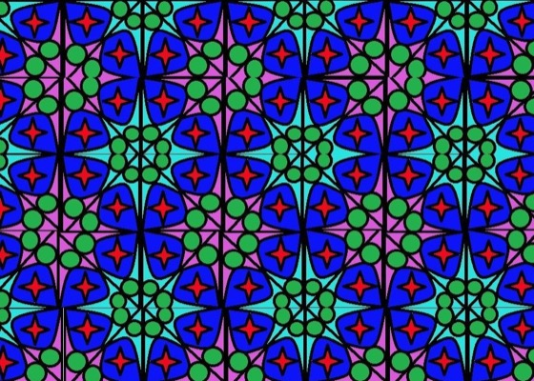
By starting small and increasing their skills over time, my students were able to create some beautiful images of which they were really proud.

Complimentary color project examples below: (not at this time)
