LAB6 – MOVE, COPY, ROTATE, & MIRROR
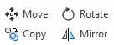

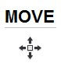
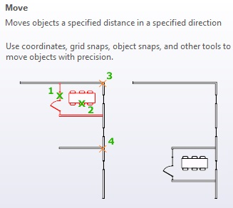
MOVE – Select Objects, Base Point, Specify Second Point

Use OBJECT SNAPS, SNAP, and coordinate entry to place objects right where you want them.

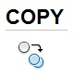
COPY - Select Objects, Base Point, Specify Second Point

After selecting the object(s) you want to COPY, pick a point to COPY from and where you want to place the next COPY. You will continue to make copies until you press <ENTER>.
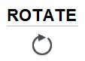
ROTATE - Select Objects, Base Point, Specify Rotation Angle
After selecting the object(s) you want to ROTATE, type the ANGLE you want to rotate or move your cursor the angle you want to turn the object(s).

Open the file “LAB 6 Clock.DWG”
Use MOVE and ROTATE to set the time to 4:00 o’clock
Make a copy of the clock and set the time to 11:30.
Save As…LAB6.DWG

Open the file “LAB 6 Door.DWG”
MIRROR the door to create another door with the hole for the knob on the left side.

