LAB5 – OBJECT SNAPS
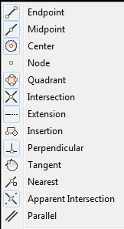
ENDPOINT The end of a LINE or ARC
MIDPOINT – The Middle of a LINE
CENTER – Center of a CIRCLE or ARC
NODE – An Assigned POINT on an Object
QUADRANT – 12 o’clock, 3 o’clock, 6 o’clock, or 9 o’clock (or 0, 90, 180, & 270 degrees)
INTERSECTION – At point that objects cross each other
PERPENDICULAR – at 90 degrees to a line or straight edge
TANGENT – Touching a CIRCLE or ARC at one point
NEAREST – select a point that touches the object closest to my mouse pointer
APPARENT INTERSECTION – The point that lines up with another object even if that object doesn’t go that far
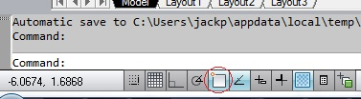
PARALLEL – Along an edge at an equal distance to an object
Turn OBJECT SNAPS on or off - <F3>
or Click on ICON (red circle)
To Change the settings, right-click on the ICON and see the list ABOVE. Select the ones you want to use. If you select all of them, it will be too much and it will SLOW you down!

To use an OBJECT SNAP one time, hold the <SHIFT> and right-click. You can do this even if your OBJECT SNAPS are off.

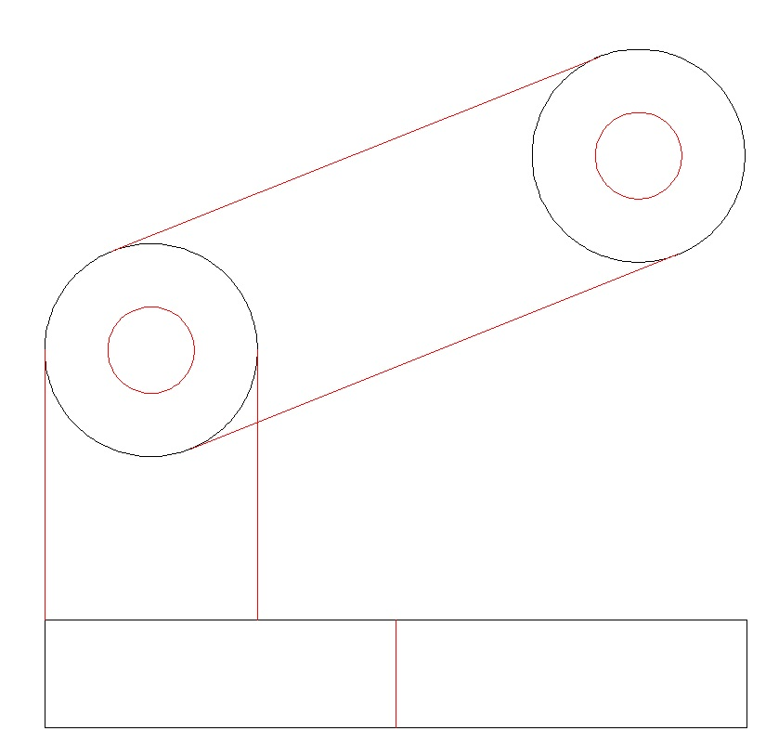
1. Open “Lab5 Start.DWG”
2. Draw a CIRCLE with a RADIUS of 2 inside of each CIRCLE you have.
3. Draw a LINE from the MIDPOINT at the top of the RECTANGLE to the MIDPOINT at the bottom of the RECTANGLE.
4. Draw a LINE from the 9 o’clock of the lower CIRCLE to the upper left corner of the RECTANGLE
5 Draw a LINE from the 3 o’clock of the lower CIRCLE to the PERPENDICULAR of the top of the RECTANGLE
6. Draw LINES TANGENT to both CIRCLES.

Save As… “LAB5.DWG”

