LAB4 – CIRCLE
CIRCLE (center point, radius); (center point, diameter); (2Pt); (3Pt); (tan, tan, radius); (tan, tan, tan)
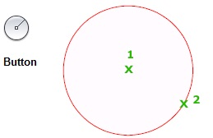

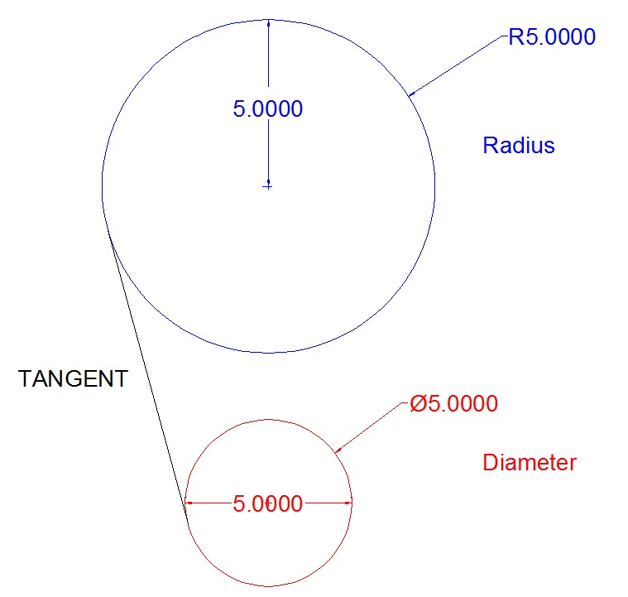

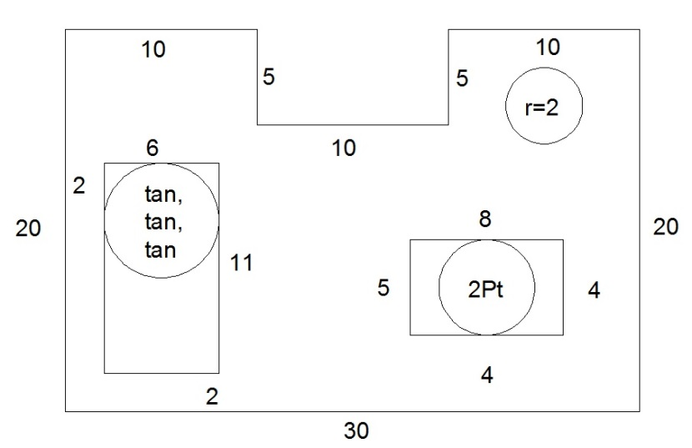
#1 Add CIRCLES using radius, 2Pt, and tan, tan, tan

SAVE AS “LAB4.DWG”

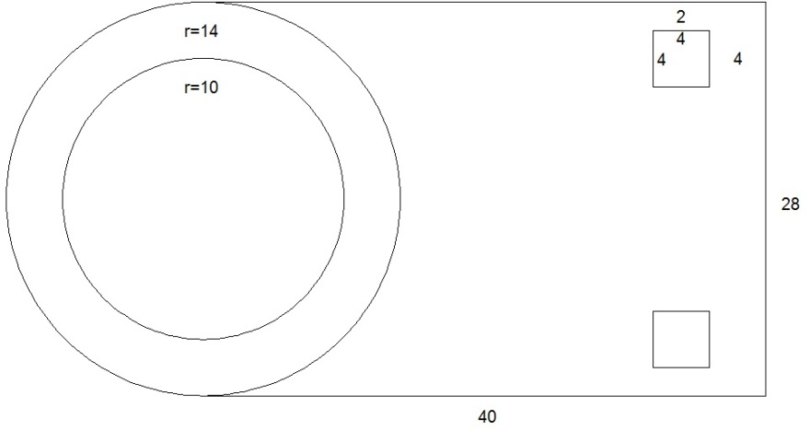
#2 Draw the Following
You will likely use CIRCLE, LINE, RECTANGLE, and maybe ERASE or UNDO.

SAVE AS “CD Holder.DWG”

