LAB2 – ERASE
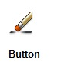
ERASE (select objects)

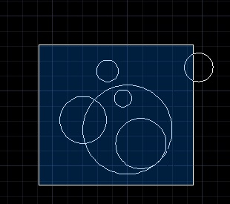
Options:

- SELECTION WINDOW – Move from left to right. Objects completely inside the window are selected. <ENTER>

- CROSSING WINDOW – Move from right to left. Any objects touching or inside the window are selected. <ENTER>
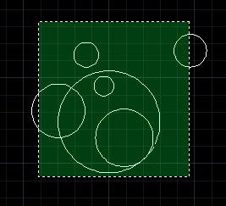

- By Clicking – Click on every object you want to delete

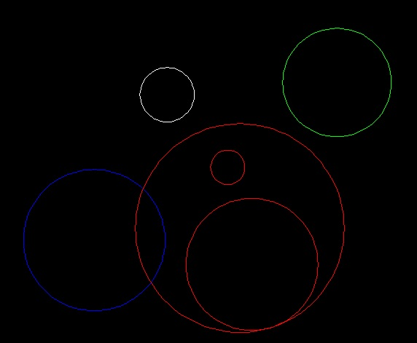
Open Erase1.dwg
#1 ERASE the red circles by selecting each red one.
#2 ERASE the red circles by using a “Selection Window”
#3 ERASE the red circles by using a “Crossing window”

YOU HAVE MASTERED ERASE!

